PHI Robotics has long shown its skill in innovation in FIRST Robotics. But this year some of the team members have decided to apply their skills to other fields outside robotics. This has allowed us to branch out and increase our skills as well as our impact on the world today.
Togo Africa Medical App.
Hannah Lokos, one of our team member's sisters, spent several months last summer on a mission trip in Togo Africa. The trip took them to a number of hospitals throughout the impoverished country. During her trip, she witnessed a number of doctors trying to fight illnesses with their limited knowledge and resources. This experience inspired an idea in her mind. She wondered if she could make a phone or tablet application that would act as a data base for these doctors to use to help diagnose their patients. Upon her return home she told her idea to her brother on the team who suggested that she ask the teams programmer if he could help her. After some discussions our programmer figured out a method for the app to work cross platform for all mobile devices. The app is still under way and has experienced a few set back but it offers some promise. It will be a cross-cultural pharmaceutical app for hospitals in Togo West Africa containing a searchable list of drugs listed by tribal, brand, and generic names. In the light of the recent outbreak of the Ebola virus in West Africa this app could have a deep and lasting impact on the medical field in under developed countries.
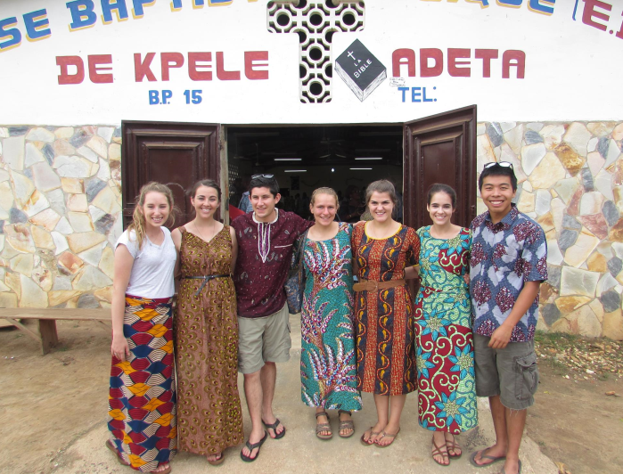

GPS Guided F35 Drone
Earlier in the school year, some of our senior members were notified in their physics class that they would have a project at the end of the year in which they would have to demonstrate some facet of physics. They decided to demonstrate the "plane in the wind" problems that show how far a cross wind will push a plane of course in a given time. They then chose to do this by equipping a model RC F35 EDF jet with an Arduino Nano and a GPS module. The plane incorporates much C programming and advanced sensors similar to the sensors used on the FTC robot. The plane is slated to fly in the last week of March.
